R is a programming language. To use R, we need to install an **Integrated Development Environment** (IDE). **Rstudio** is the Best IDE available as it is user-friendly, open-source and is part of the Anaconda platform.

[I](https://www.guru99.com/download-install-r-rstudio.html" \l "13)

## **Install Anaconda**

**What is Anaconda?**

Anaconda free open source is distributing both Python and R programming language. Anaconda is widely used in the scientific community and data scientist to carry out Machine Learning project or data analysis.

**Why use Anaconda?**

Anaconda will help you to manage all the libraries required for Python, or R. Anaconda will install all the required libraries and IDE into one single folder to simplify package management. Otherwise, you would need to install them separately.

### **Mac User**

**Step 1) Go to**[**https://www.anaconda.com/download/**](https://www.anaconda.com/download/)**and Download**Anaconda for Python 3.6 for your OS.

By default, Chrome selects the downloading page of your system. In this tutorial, installation is done for Mac. If you run on Windows or Linux, download Anaconda 5.1 for Windows installer or Anaconda 5.1 for Linux installer.

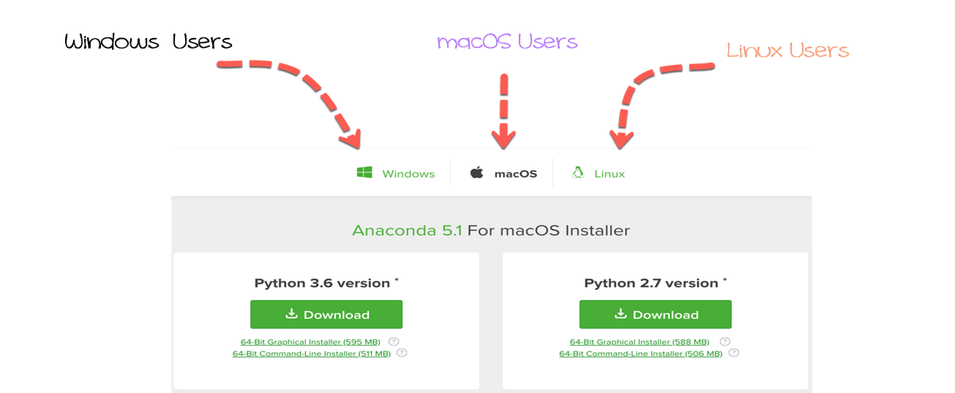

**Step 2)**You are now ready to install Anaconda. Double-click on the downloaded file to begin the installation. It is .dmg for mac and .exe for windows. You will be asked to confirm the installation. Click **Continue** button.

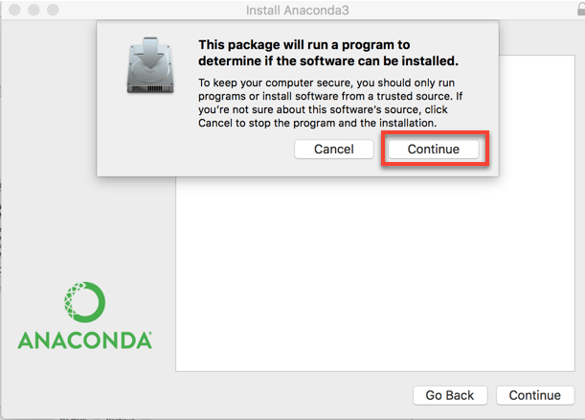

You are redirected to the **Anaconda3 Installer**.

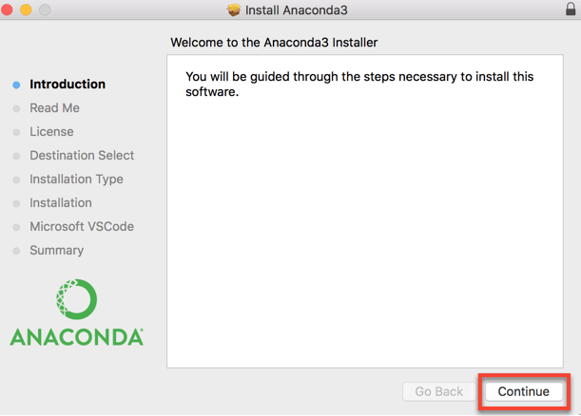

**Step 3)** Next window displays the **ReadMe**. After you are done reading the document, click **Continue**

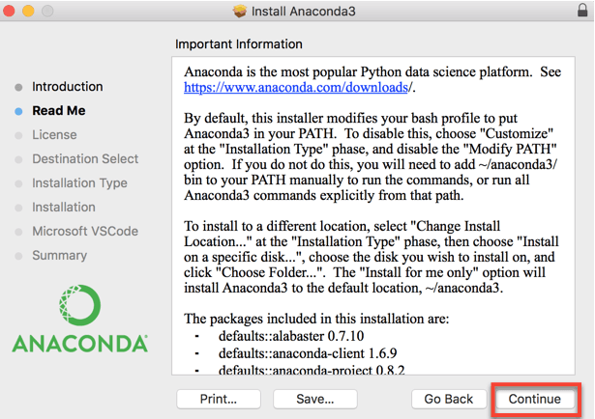

**Step 4)** This window shows the Anaconda End User License Agreement. Click Continue to agree.

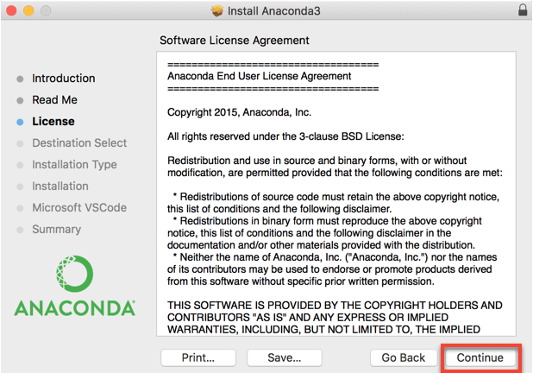

**Step 5)** You are prompted to agree, click **Agree** to go to the next step.

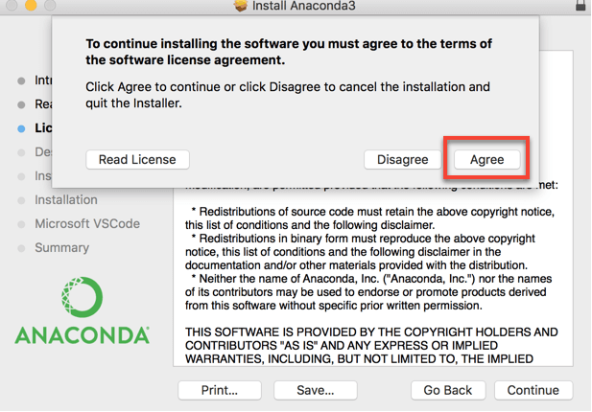

**Step 6)** Click **Change Install Location** to set the location of Anaconda. By default, Anaconda is installed in the user environment: **Users/YOURNAME/**.

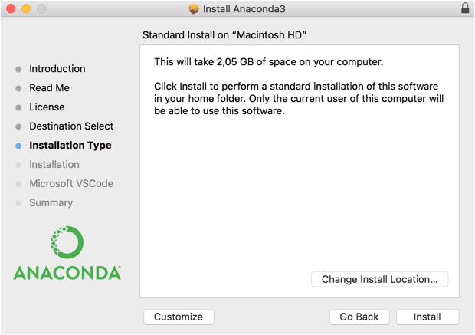

Select the destination by clicking on **Install for me only**. It means Anaconda will be accessible only to this user.

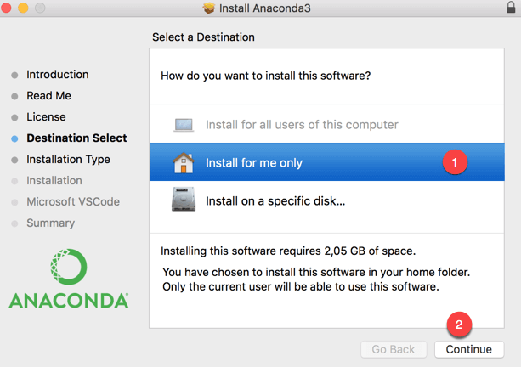

**Step 7)** You can install Anaconda now. Click **Install** to proceed. Anaconda takes around 2.5 GB on your hard drive.

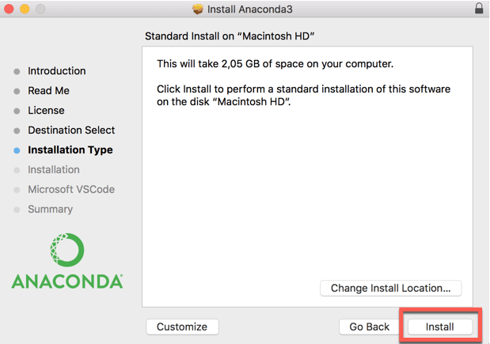

A message box is prompt. You need to confirm by typing your password. Hit **Install Software**

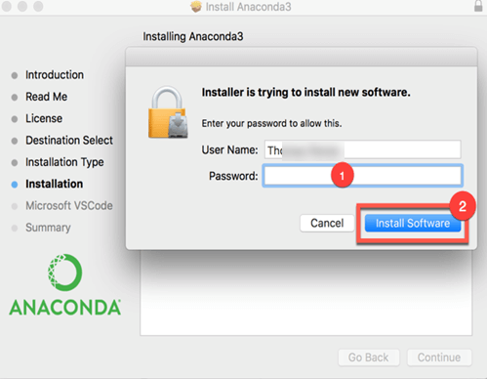

The installation may take sometimes. It depends on your machine.

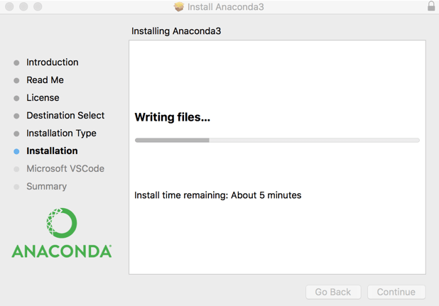

**Step 8)** Anaconda asks you if you want to install Microsoft VSCode. You can ignore it and hit Continue

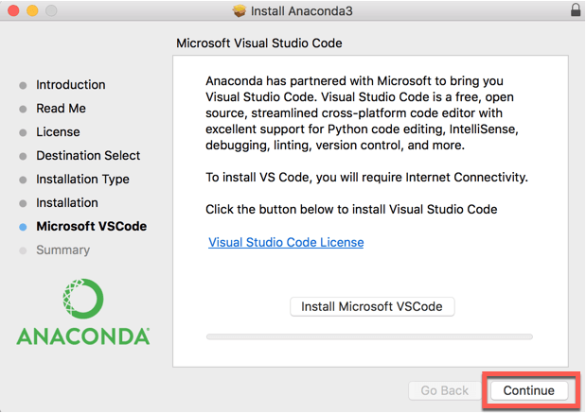

**Step 9)** The installation is completed. You can close the window.

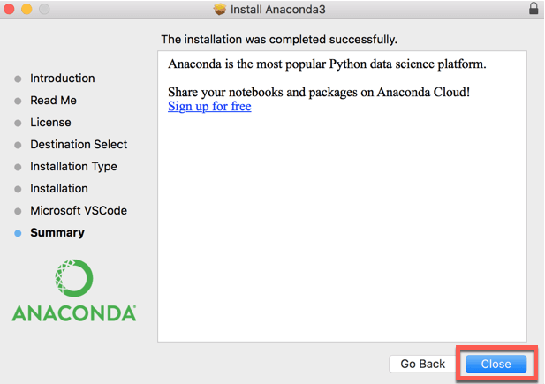

You are asked if you want to move "Anaconda3" installer to the Trash. Click **Move to Trash**

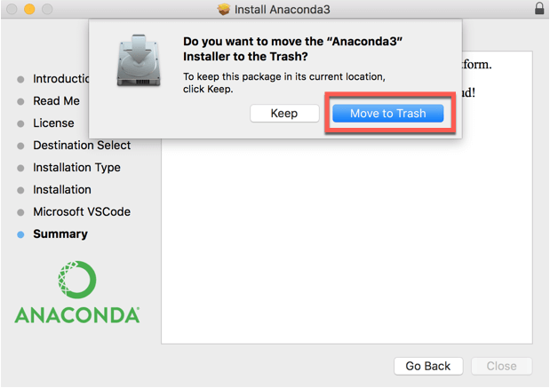

**You are done with the installation of Anaconda on a macOS system**

### **Windows User**

**Step 1)**Open the downloaded exe and click Next

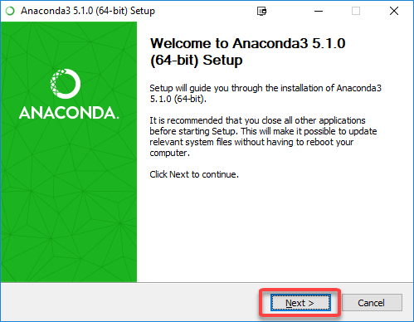

**Step 2)**Accept the License Agreement

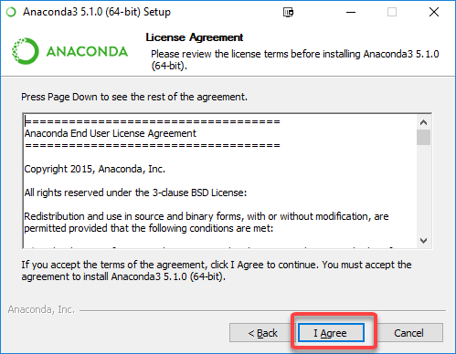

**Step 3)**Select Just Me and click Next

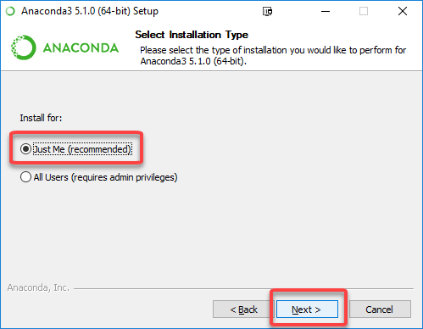

**Step 4)**Select Destination Folder and Click Next

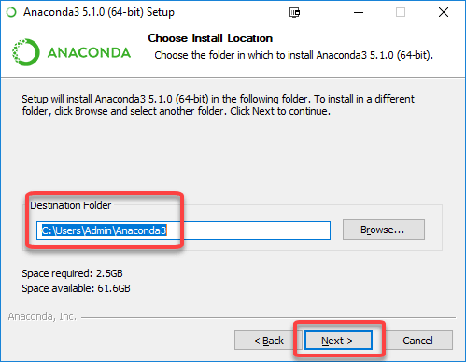

**Step 5)**Click Install in next Screen

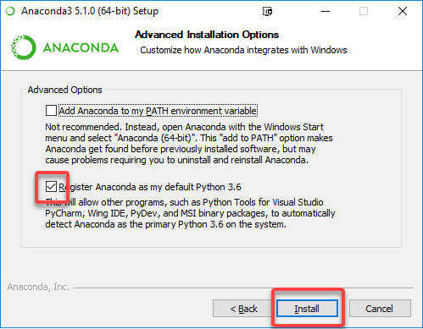

**Step 6)**Installation will begin

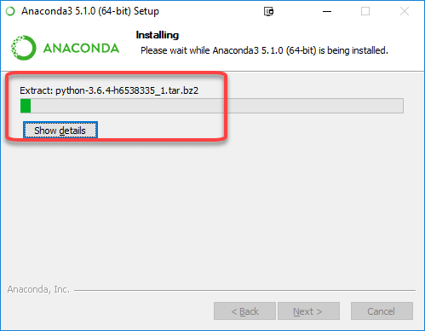

**Once done, Anaconda will be installed.**

## **Install R**

### **Mac users**

**Step 1)**Anaconda uses the **terminal** to install libraries. The terminal is a quick way to install libraries. We need to be sure to point the installation toward the right path. In our case, we set the location of Anaconda to the **Users/USERNAME/**. We can confirm this by checking **anaconda3** folder.

Open **Computer** and select **Users**, **USERNAME** and **anaconda3**. It confirms that we installed Anaconda on the right path. Now, let's see how macOS write the path. Right-click, and then **Get Info**

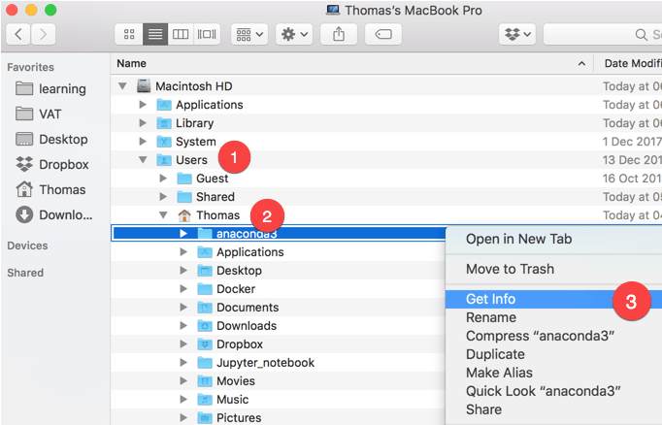

Select the path **Where** and click **Copy**

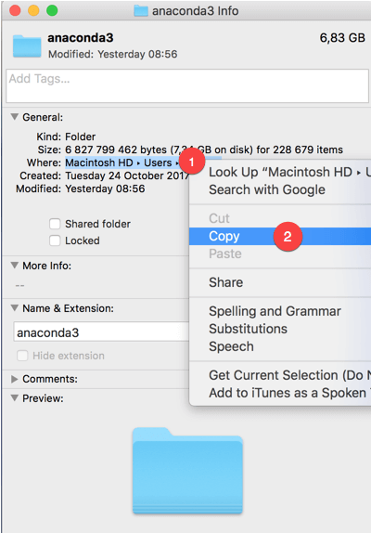

**Step 2)** For Mac user:

* The shortest way is to use the **Spotlight Search** and write **terminal**.

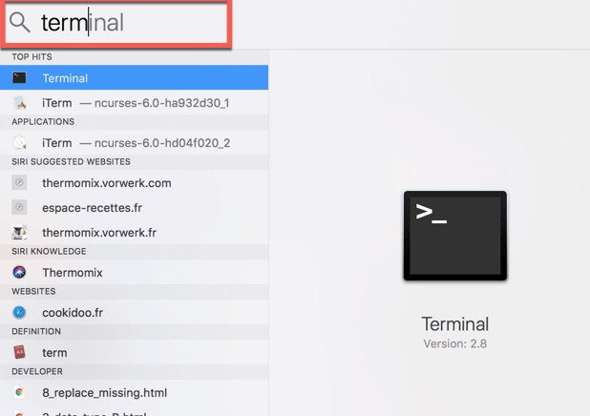

The terminal sets the default working directory to **Users/USERNAME**. As you can see in the figure below, the path of **anaconda3** and the working directory are identical. In macOS, the latest folder is shown before the **$**. For me, it is **Thomas**. The terminal will install all the libraries in this working directory.

If the path on the text editor does not match the working directory, you can change it by writing cd PATH in the terminal. **PATH** is the path you pasted in the text editor. Don't forget to wrap the PATH with **"PATH"**. This action will change the working directory to **PATH**.

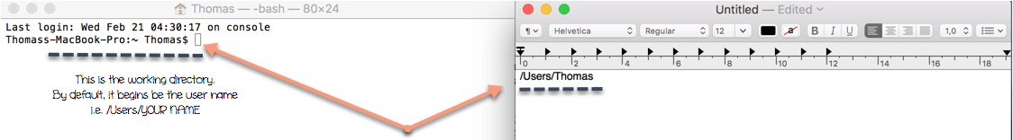

**Step 4)** We are ready to install R. I recommend you to install all packages and dependencies with the conda command in the terminal.

## In the terminalconda install r-essentials --yes

r-essentials means conda will install **R** and all the necessary libraries used by data scientist.

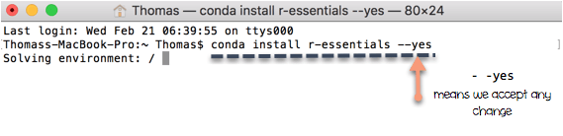

**Conda** is downloading the libraries

It takes some time to upload all the libraries. Be patient...you are all set.

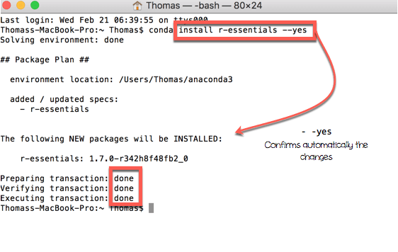

In the terminal, you should see Executing transaction: done. If so, you have successfully installed **R**.

You can check where R is located.

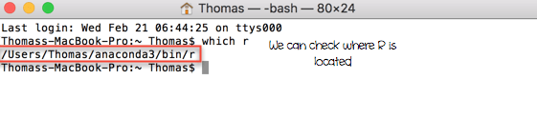

### **Windows User**

**Step 1)** Open the Anaconda command prompt

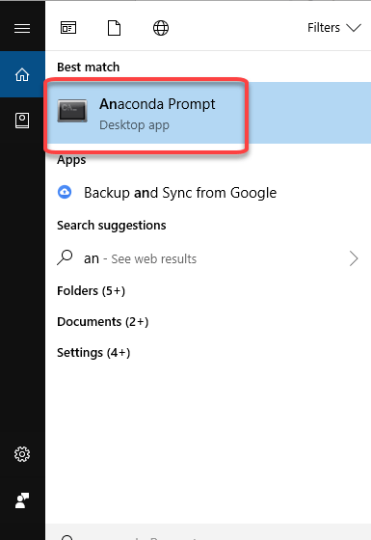

**Step 2)** In the command prompt

1. Enter the R install command
2. Environment will be determined
3. List of packages to be installed will be listed

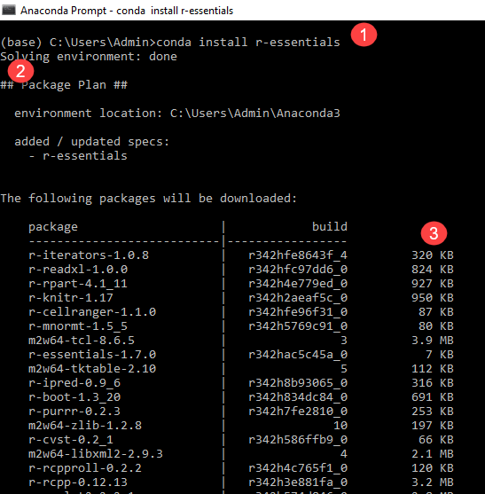

**Step 3)** Enter y and hit the return key to start installation

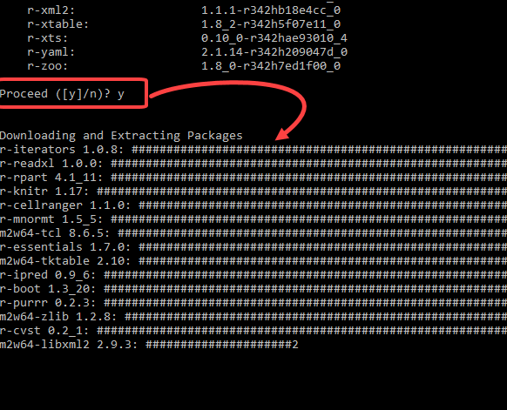

**Step 4)** Installation will take time, and you will get done message.

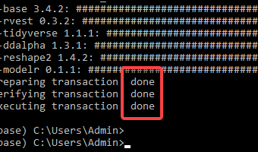

## **Install Rstudio**

### **Mac User**

In the terminal, write the following code:

## In the terminalconda install -c r rstudio --yes

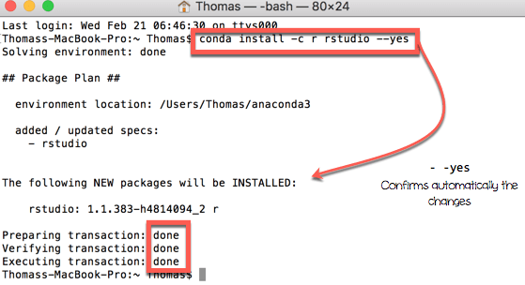

In the terminal, you should see Executing transaction: done. If so, you have successfully installed **Rstudio**.

You are all set now, congratulation!

### **Windows User**

**Step 1)** Enter command to install R Studio in the Anaconda prompt

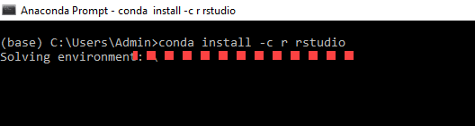

**Step 2)** You will be shown a list of packages that will be installed. Enter y

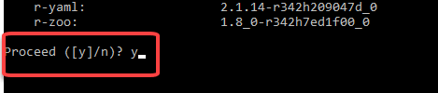

**Step 3)** R Studio will be installed

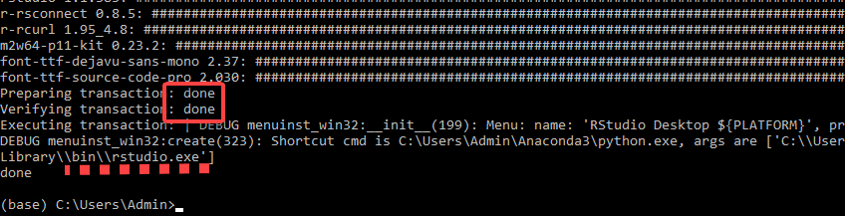

**Warning**

Avoid as much as you can to install a library using pip for Python, and R. Conda libraries gather a lot of packages, you don't need to install libraries outside of conda environment.

## **Run Rstudio**

Directly run the command line from the terminal to open Rstudio. You open the terminal and write rstudio. You can also use Desktop Shortcut

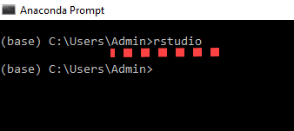

Or

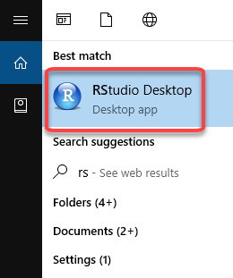

A new window will be opened with **Rstudio**.

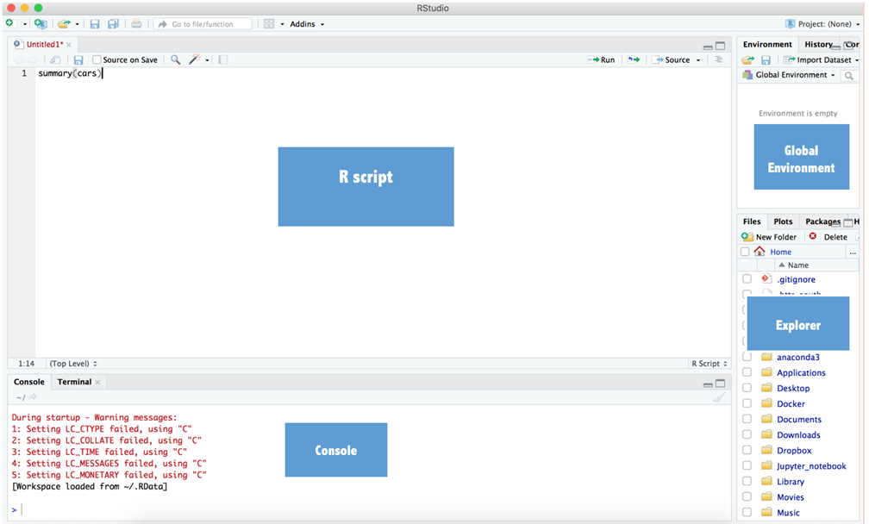

## **Test**

Open Rstudio from the terminal and open a script. Write the following command:

1. ## In Rstudio **summary**(cars)
2. Click Run
3. Check Output

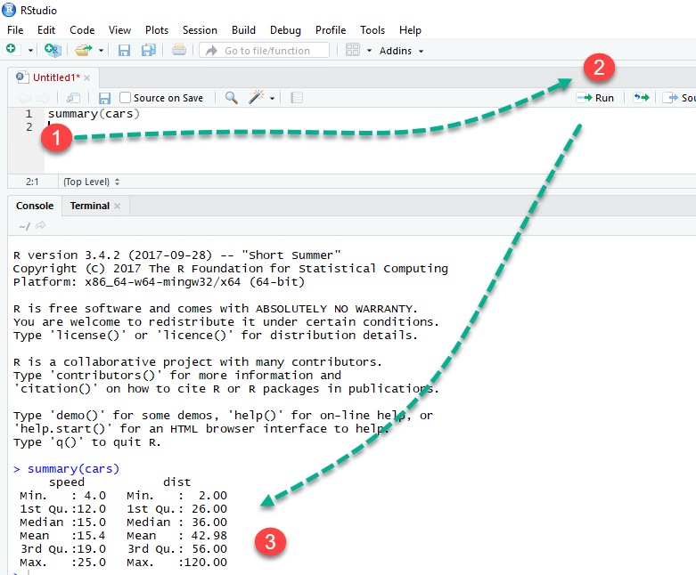

If you can see the summary statistics, it works. You can close Rstudio without saving the files.

## **Install package**

Install package with anaconda is trivial. You go to your favorite browser, type the name of the library followed by **anaconda r**.

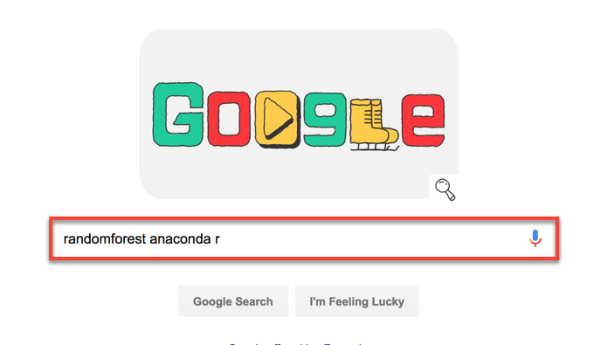

You choose the link that points to anaconda. You copy and paste the library into the terminal.

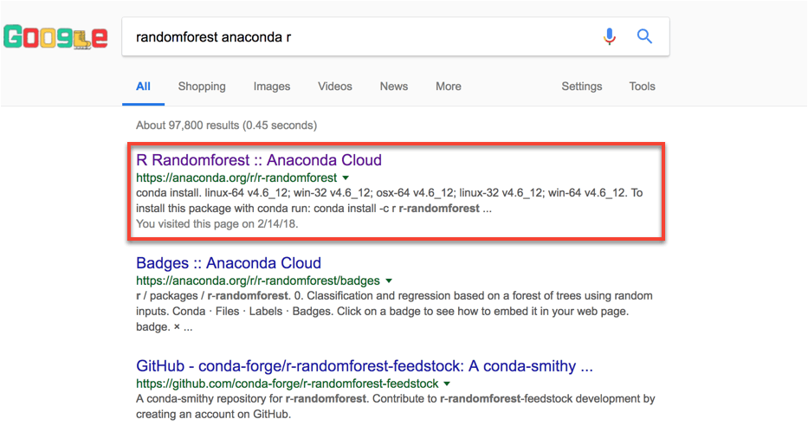

For instance, we need to install randomForest for the tutorial on random forest; we go [**https://anaconda.org/r/r-randomforest**](https://anaconda.org/r/r-randomforest)**.**

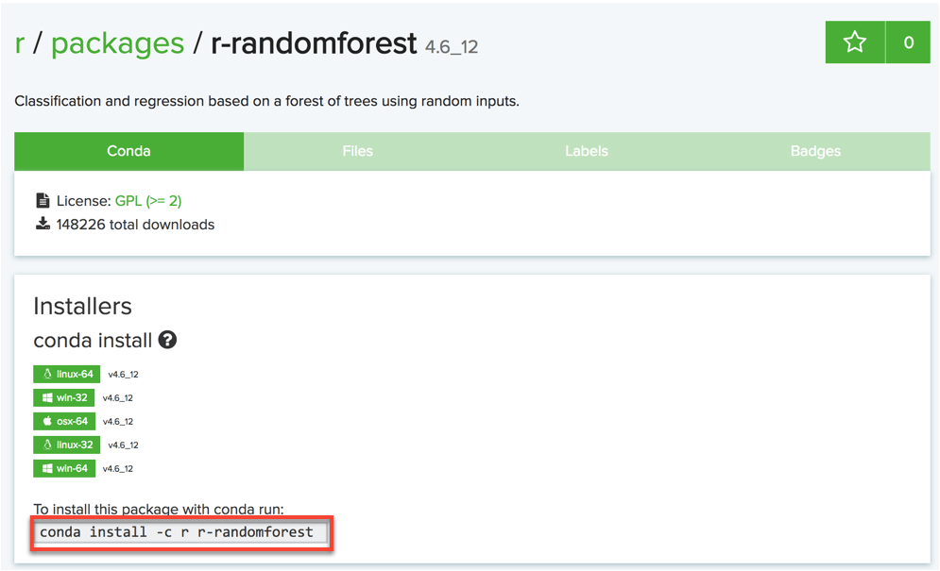

Run conda install -c r r-randomforest --yes from the terminal.

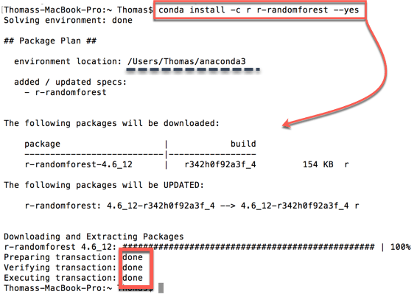

The installation is completed.

Note that Thorough this tutorial, you won't need to install many libraries as the most used libraries came with the r-essential conda library. It includes ggplot for the graph and caret for the machine learning project.

## **Open a library**

To run the R function randomForest(), we need to open the library containing the function. In the Rstudio script, we can write library(randomForest)

## In Rstudiolibrary(randomForest)

## randomForest 4.6-12

## Type rfNews() to see new features/changes/bug fixes.

**Warning:**Avoid as much as possible to open unnecessary packages. You might ended up creating conflicts between libraries.

## **Run R code**

We have two ways to run codes in R

1. We can run the codes inside the Console. Our data will be stored in the Global Environment but no history is recorded. We won't be able to replicate the results once R is closed. We need to write the codes all over again. This method is not recommended if we want to replicate our save our codes

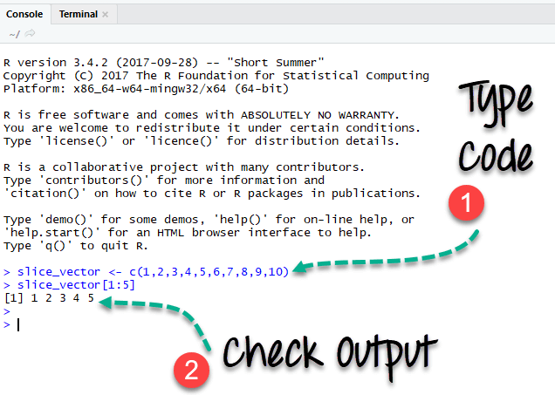

1. Write the code in the script. We can write as many lines of codes as we want. To run the code, we simple select the rows we want to return. Finally, click on run. We can see the output in the Console. We can save our script and open it later. Our results won't we lost.

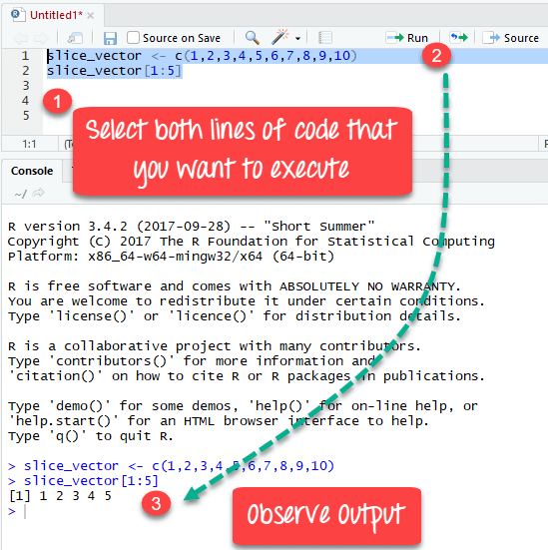

**Warning**: In we point the cursor at the second row (i.e., slice_vector[1:5]), the Console displays an error. That's, we didn't run the line number 1.

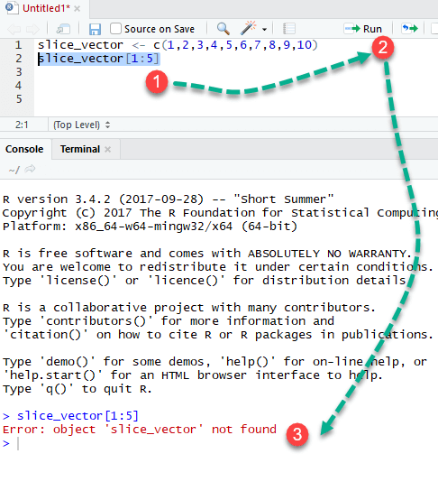

Similarly, if we point the cursor to an empty row and click on run, R return an empty output.

